**Semester: V Name of Student:**

**Academic Year: 2022-23 Student ID:**

**Class / Branch: TE IT**

**Subject: Advanced Devops Lab (ADL)**

**Name of Instructor: Prof. Manasi Choche**

**EXPERIMENT NO. 08**

**Aim: Create a Jenkins CICD Pipeline with SonarQube / GitLab Integration to perform a static analysis of the code to detect bugs, code smells, and security vulnerabilities on a sample Java application.**

**Steps:**

**1) Install and configure a Jenkins and SonarQube CICD environment using Docker containers.**

**2) Configure Jenkins with the SonarQube Scanner plugin for automated static code analysis.**

**3) Create and set up a Jenkins build pipeline using a Jenkinsfile stored within a GitHub repo.**

**4) Use the SonarQube web application to examine and review the generated static analysis report.**

**5) Use the Blue Ocean Plugin to review Pipeline Steps.**

**Note: From Step 1 and 2 we have already done in Expt. 7 as a Pre-requiste required for Integration settings of Jenkins SAST with SonarQube so in this Experiment we will continue from 3rd Step.**

Check the contents of jenkins-sonarqube repository which we are using for Pipeline Project.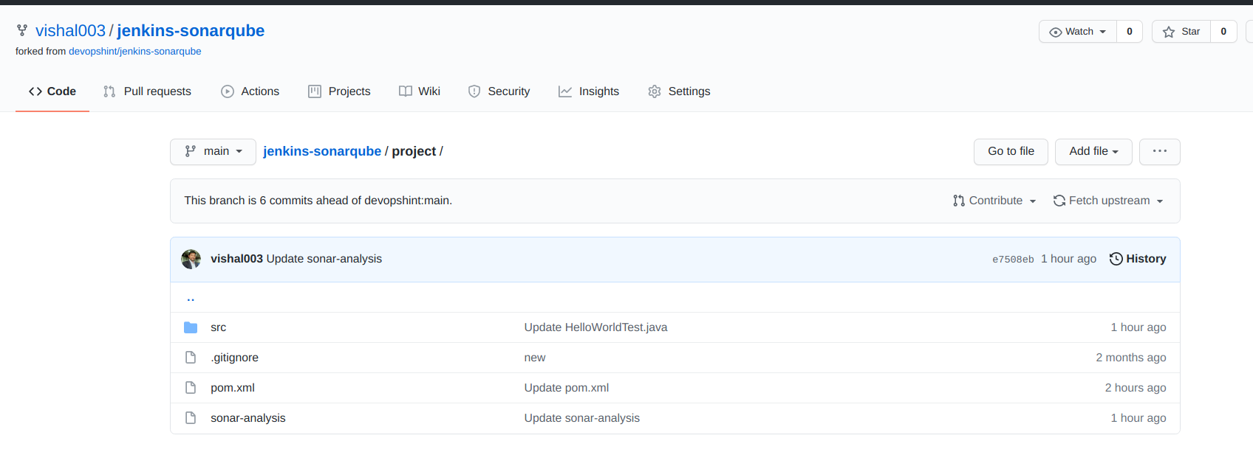

**Check path for the Source and Test Java Programs from repository** 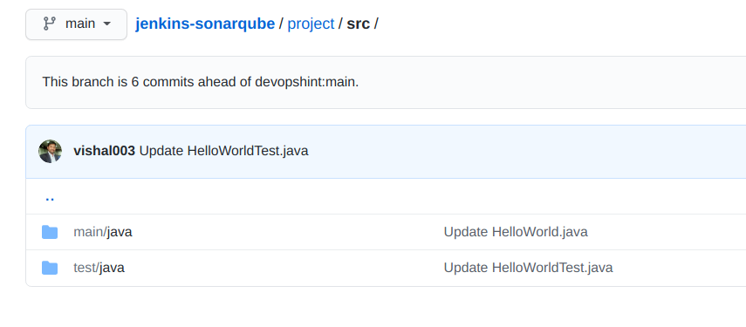

**Provide sonar host as** [**http://127.0.0.1:9000**](http://127.0.0.1:9000/) **in POM.xml which is available in Project on Github.**

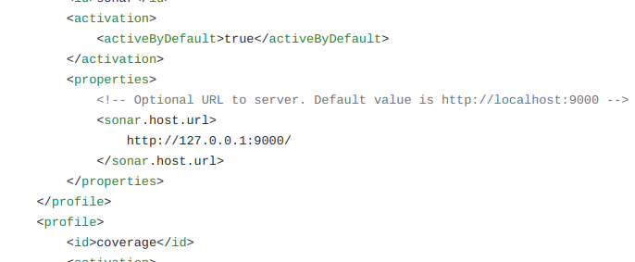

To integrate the SonarQube Scanner in the Jenkins Pipeline. For the same, we are going to add one more stage in the Jenkinsfile called SonarQube and inside that, I am adding the following settings and code.

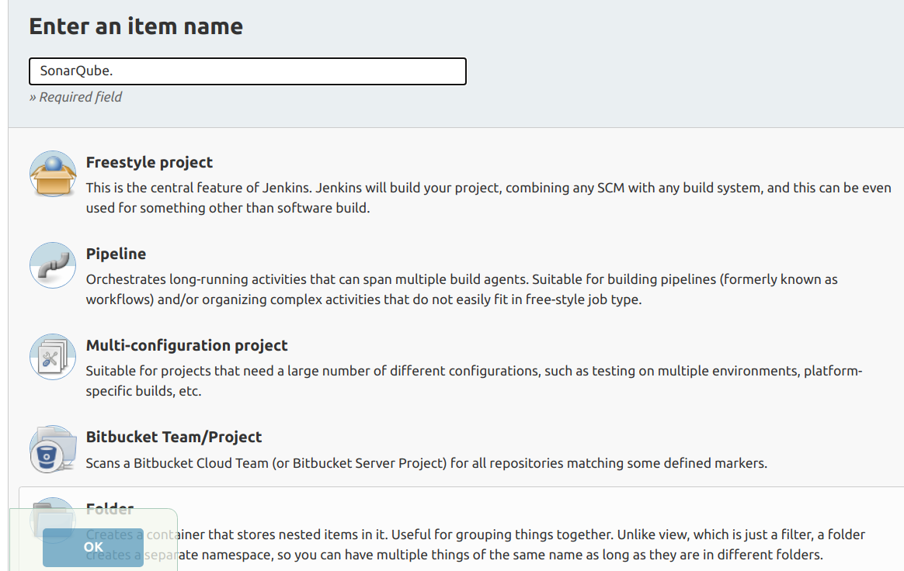

**Github Repository Configuration in Jenkins Pipeline Project**

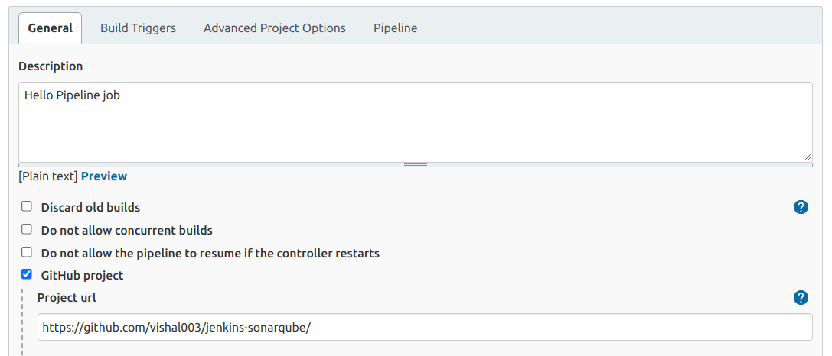

**Pipeline Script where stages are written along with scanner tool, repository path for source and test Java sample program, SonarQube Credential for integration, Application name on sonarqube, code language,etc.**

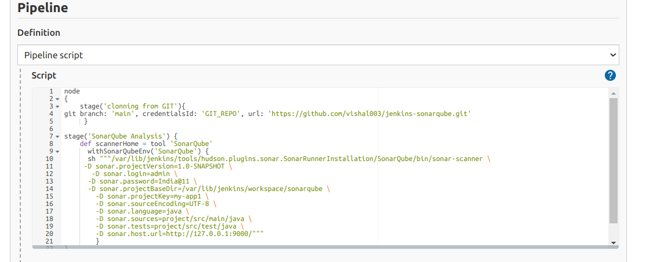

**After creating a Pipeline Script Build it in Jenkins , Click on save and then Click on Build Now**

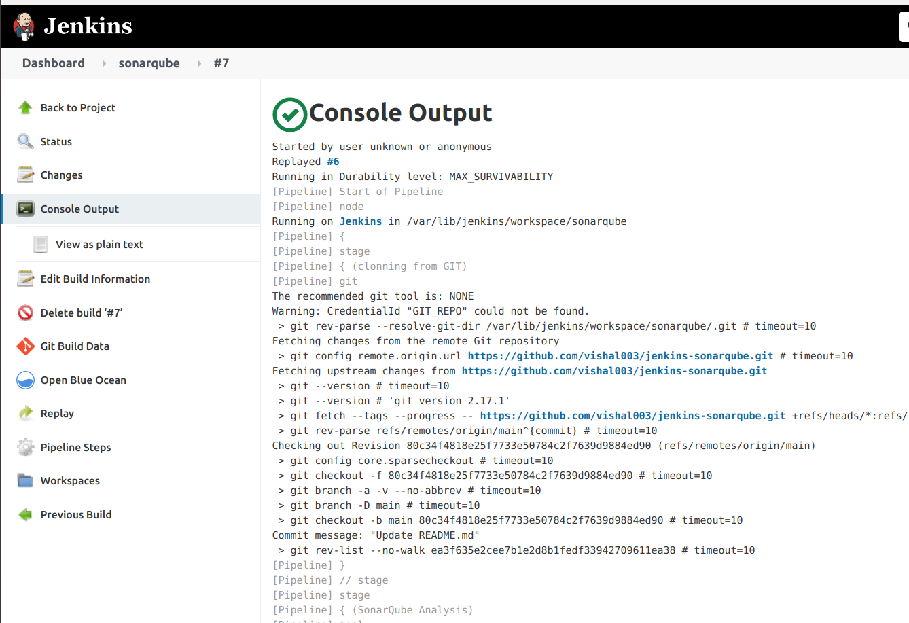

**Click on Console Output to check output whether build is successful or not.**

**Click on Pipeline Steps to check Sequence of events during building of pipeline.**

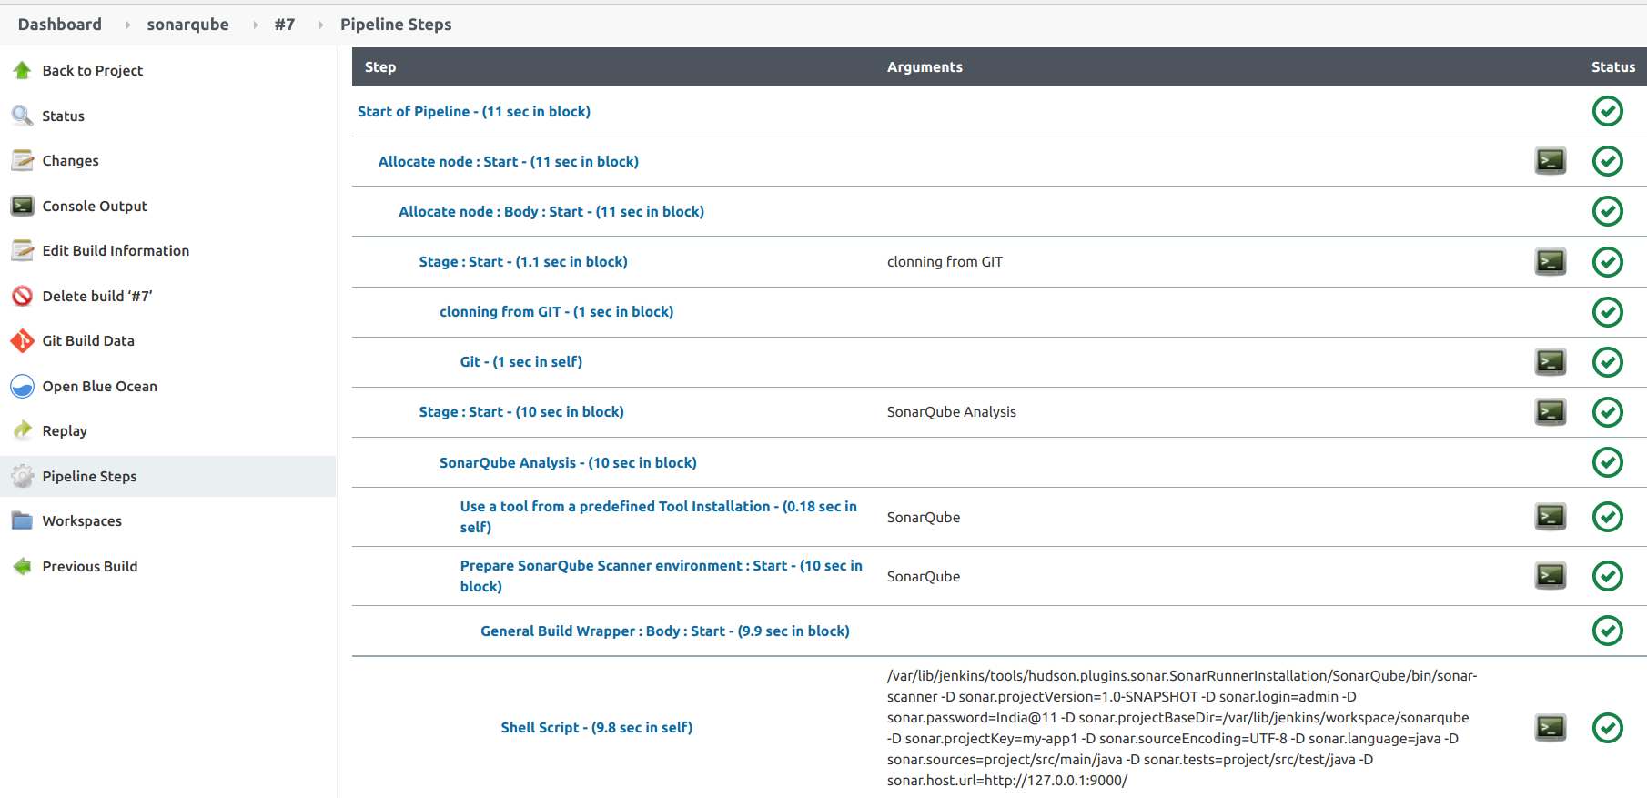

**Also you can use Blue Ocean to check Pipeline execution stage by stage and log of the pipeline too.**

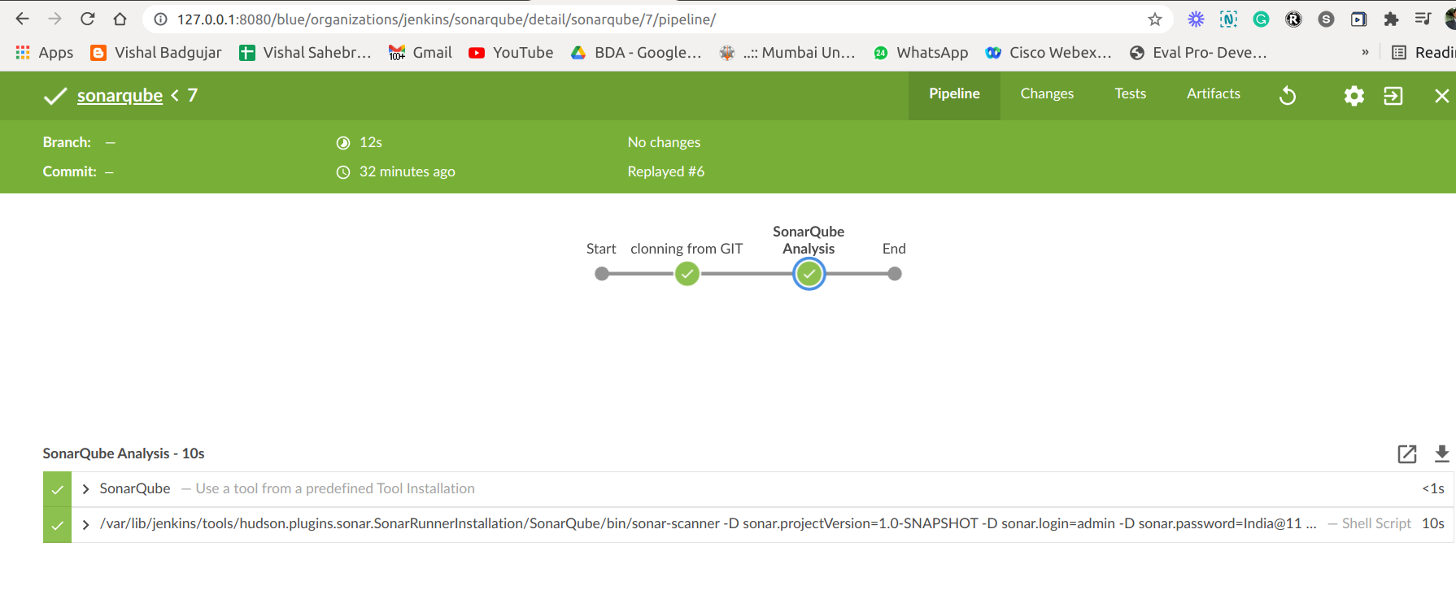

**If you login to the SonarQube and visit the Dashboard, you will see the Analysis of the project there.**

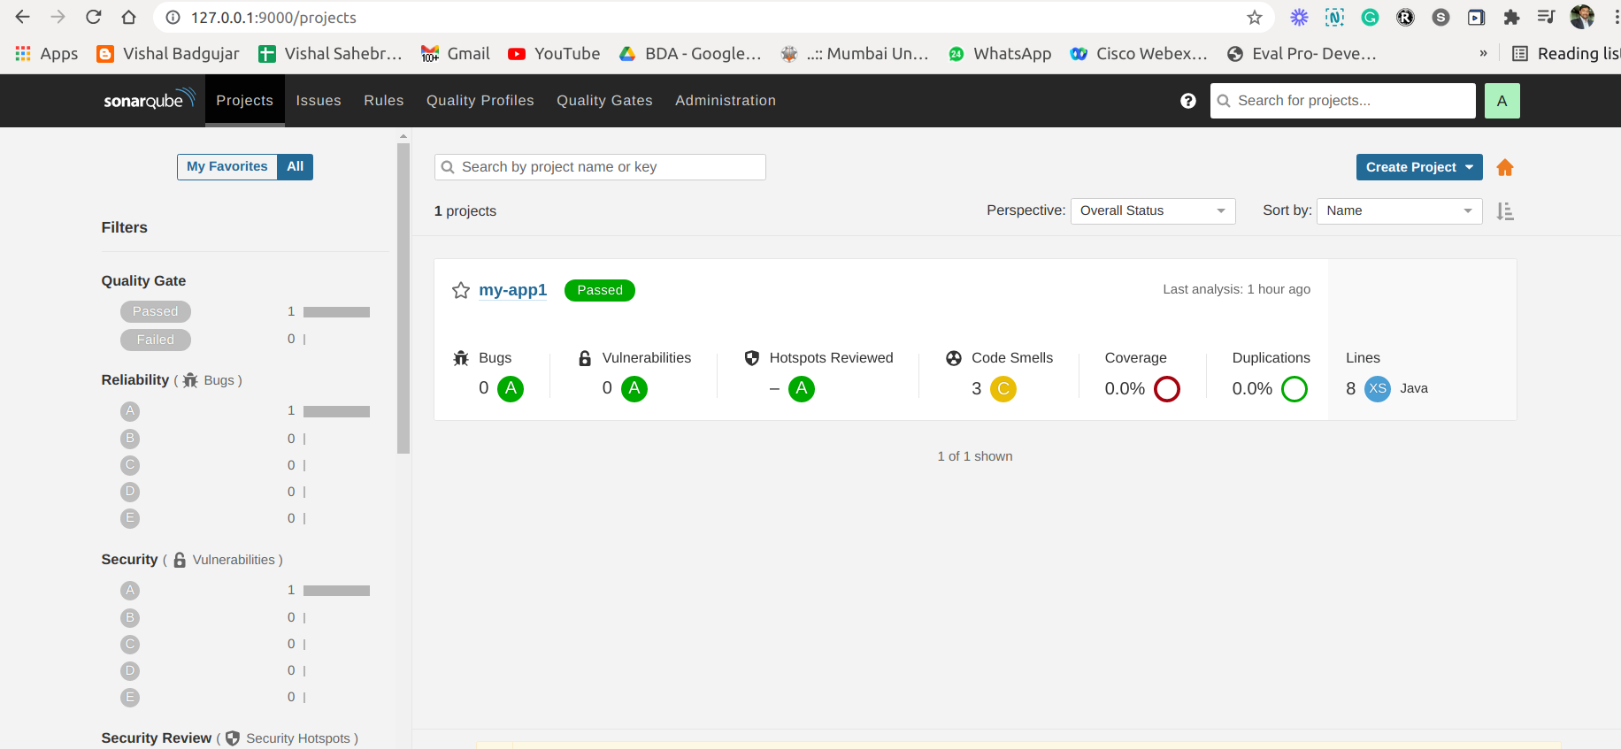

**For Detailed Report for code analysis you can go to application overview and check for all Bugs, Vulnerabilities, code smells and all parameters as shown in below image.**

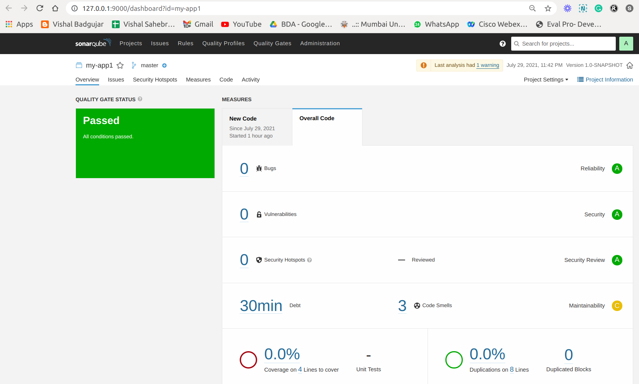

Since we have both Jenkins and SonarQube in the Enterprise standard, we have a lot of features including the alert system. Where we can configure the Email, or Instance message Notification system for the findings in the SonarQube or Jenkins. In the best case, we can auto convert certain bugs or findings as ticket and assign to the respective developer as a one option.

**Conclusion: Write your own findings.**